**Unit-1 Chapter-1 Lecture-1.1**

**Introduction to Machine Learning**

**What is Machine Learning?**

Machine Learning is the most popular technique of predicting the future or classifying information to help people in making necessary decisions. Machine Learning algorithms are trained over instances or examples through which they learn from past experiences and also analyze the historical data. Therefore, as it trains over the examples, again and again, it is able to identify patterns in order to make predictions about the future.

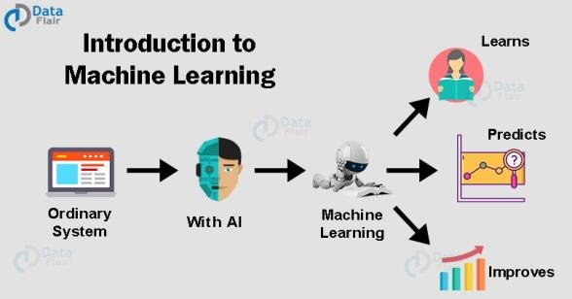

**Fig 1.1- Machine learning**

**Machine Learning Applications in Real World**

As we move forward into the digital age, One of the modern innovations we’ve seen is the creation of Machine Learning. This incredible form of artificial intelligence is already being used in various industries and professions. These Applications of Machine Learning shows the area or scope of Machine Learning.

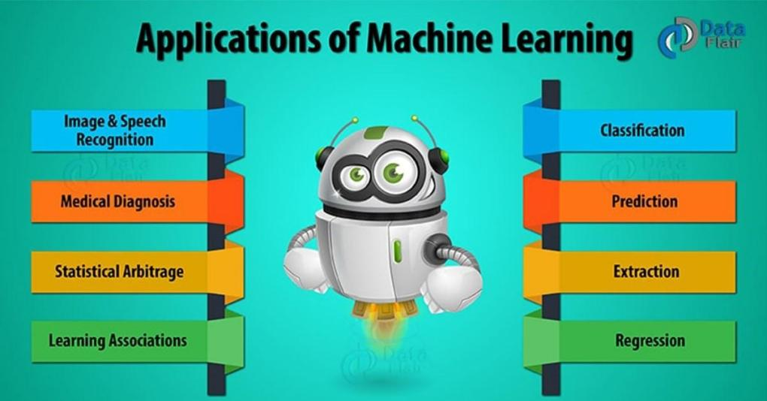

**Fig 1.2- Machine learning Applications**

**Why is Machine Learning so popular?**

Machine learning is an application of artificial intelligence (AI). The system provided by ML has the ability to automatically learn and improve from past experiences. So, they can perform without being explicitly programmed. It focuses on the development of computer programs that can access data and use it to learn for themselves.

In simple terms, this field of computer science provides computers the ability to learn without being explicitly programmed. It provides algorithms that can be trained to perform a task.

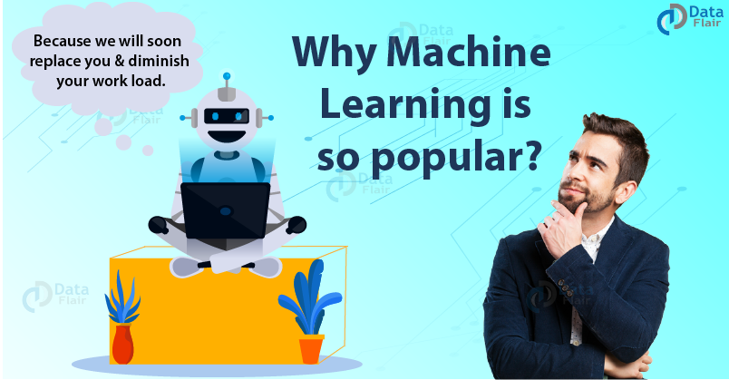

**Fig 1.3- Machine learning Popularity**

**Reasons why machine learning is popular**

The modern challenges are “high-dimensional” in nature.

With rich data sources, it is important to build models that solve problems in high-dimensional space.

Through it, the models can be integrated into working software. It supports the kinds of products that are being demanded by the industry.

Also, Google Trends that tracks the popularity of search terms, suggests that searches for machine learning are about to out-pace the searches for artificial intelligence. Machine Learning is moving beyond the textbooks and is creating a disruption that will revolutionize the future.

Now, let’s learn in detail – why machine learning is gaining popularity –

**1. To sort prolific and unstructured data**

A lot of information is available today because of ***the Internet of Things***. It is not possible to manage every information or data coming from email, social networking, blogs, podcasts, or any other source for that matter. Also, to keep that information in a structured manner it is also necessary to keep up with the trend and gain a competitive edge.

If blunders like missing useful content occurs then a business might lose a fortune. No one knows where the idea can come from and strike you.

***For e.g: Jennifer Lopez’s Grammys award green dress inspired Google to come up with the image search feature. Search it and you will be awestruck too(and can thank Google too).***

For marketers, the stress of finding and tracking the best content is very real. But, Machine Learning is a savior for them. It helps them to provide the tools to locate and recommend the most relevant content in order to overcome information overload.

**What are the sources of this Data?**

This happens because of the digital footprint.

Before talking about this, we can thank the Government for Digitalisation and Jio for Mobile Data. With so much consumption of data two types of footprints are released.

**Passive digital footprints**

It is collected without the owner knowing (also known as data exhaust) that data about him is getting collected. This type of footprint is stored in an online database as a “hit”. It tracks the user’s IP address. With that, it keeps a hold on the day and time it got created and from where did the data come. This footprint can be stored in files, which can be accessed by administrators. It helps to view the actions performed on the machine, without seeing who performed them.

**Active digital footprints**

Active digital footprints are created when personal data is released deliberately which means he is aware that his actions are recorded. This is done for the purpose of sharing information about oneself by means of websites or social media platforms.

Machine learning is smart and it is very simple for the other parties to collect a whole lot of information and come to a conclusion. A lot of information can be gathered from that individual by using simple search engines.

**2. Abundant data help in recommendations**

***“We now have rich data sources to build models that solve problems in high-dimensional space”***

We all watch Youtube (Netflix, Hotstar, or Television) for that matter. During my childhood days, I used to think that the TV and I have a similar liking, and all my favorite shows broadcast on it. Little did I know that data was the reason behind it.

With the abundance of data, people liking and disliking were all kept in mind before the director thought of making a show.

There is an abundance of data right now, and data that is being collected and stored. “Information overload” is happening and quality is the thing which everyone is looking for. So much information spamming us day to day, starting from email, social networking, blogs, podcasts (and the never-ending list).

It’s impossible to keep up altogether. But, not anymore. Now, there will be no more concerns about missing useful content and the stress of finding and tracking the best content to be there. With Machine Learning methods the tools to locate and recommend the most relevant content are present. So now you can overcome the information overload, take a back seat because everything is sorted.

**3. Quantified Self?**

With quantified self-tracking your health is possible. Your everyday data is getting collected. Your everyday information like starting from the biological information like heartbeats, breaths, steps, to the interactions such as conversations and words spoken by you, are taken a record of. Mobiles are covered in sensors that can monitor orientation, location, audio and video of the surrounding area

These streams of data can meet at confluence points like people, locations, and organizations and questions can be answered that had not even been conceived could be answerable. This is one of the major reasons why machine learning is popular.

**4. Need Some Motivation? Your Machine is there for Triggering Intervention!**

You might not believe me, but your mental state (like lethargy, boredom or procrastination) can be solved. Irrespective of your location (home, office, or around the world) you will get triggering interventions. You can’t help it (shouldn’t even try) cause you will get inspiring targeted action. This will help you to optimize your goals like efficiency, effectiveness, or productivity.

This method provides the capability to model complex problems using large volumes of seemingly disparate data.

**5. Abundant Computation**

A lot of calculation leads to confusion, frustration, and no solution. It’s true that computation is abundant and it is cheap. So, you can be Aryabhatta too, and with the abundance master the art of structuring.

The world has changed and a lot is there to explore. With the powerful computers, you can rent one at cents and run large experiments on immense data sets.

Now, with this, you don’t need to write scripts and programs for long runs of algorithms. You now don’t have to think hard about what question you want to answer (like which algorithm is better, and which parameters should be considered). You can write a script or a program and run the experiment overnight.

So while you chill or are at work, you can let the computer do the talking. The systems now do more than they used to do.

Machine Learning has made everything so cheap that it can actively design systems to siphon cycles away from core activities. The important fact why machine learning is so popular.

**Machine Learning is the Future**

***Powerful methods have been developed. The principles are well understood in statistical and probabilistic frameworks.***

Technocrats were aware already, but now users are getting aware too. The field has matured a lot in the last decade and has changed a lot in the last few years.

We know that Machine Learning is the brainchild of artificial intelligence. It was a collection of methods that learned from data or experience. Genetic algorithms and swarm intelligence were considered methods that learn from their environment. The maturation promoted a statistical and probabilistic underpinning for the methods in the field.

So, now the gist that maturation of machine learning brings to us is that in no time it will be a mainstream field and people will work and be dependent on Machine learning.

**Advantages and Disadvantages of Machine Learning**

Amidst all the hype around Big Data**[,](https://data-flair.training/blogs/what-is-big-data/)** we keep hearing the term “Machine Learning”. Not only does it offer a remunerative career, it promises to solve problems and also benefit companies by making predictions and helping them make better decisions. In this blog, we will learn the Advantages and Disadvantages of Machine Learning. As we will try to understand where to use it and where not to use Machine learning.

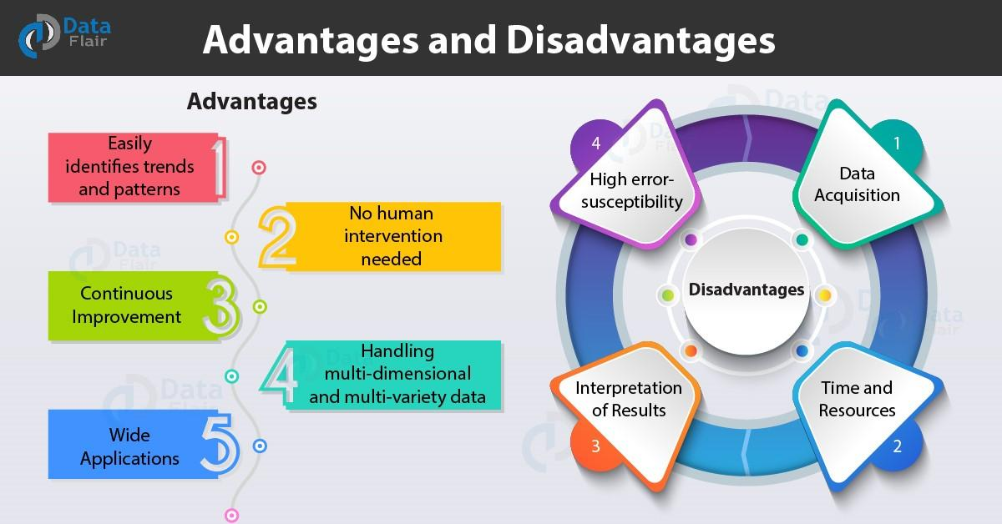

**Fig 1.4- Machine learning Pros and Cons**

**Book Reading and Video Material**

* Understanding Machine Learning: From Theory to Algorithms by Shai Shalev-Shwartz and Shai Ben-David-Cambridge University Press 2014 [Download](https://www.cse.huji.ac.il/~shais/UnderstandingMachineLearning/understanding-machine-learning-theory-algorithms.pdf) Buy at Amazon
* Introduction to Machine Learning – the Wikipedia guide [Download](http://datascienceassn.org/sites/default/files/Introduction%20to%20Machine%20Learning.pdf)
* [Weblink (towardsdatascience)](https://towardsdatascience.com/machine-learning-an-introduction-23b84d51e6d0)
* [Online Reading Material(Research gate)](https://www.researchgate.net/publication/323108787_Introduction_to_Machine_Learning)
* [NPTEL VIDEO](https://www.youtube.com/watch?v=T3PsRW6wZSY&feature=youtu.be)

**P-1.1-ML intro.pptx**